Screenshots that all tasks are completed in three sprints.

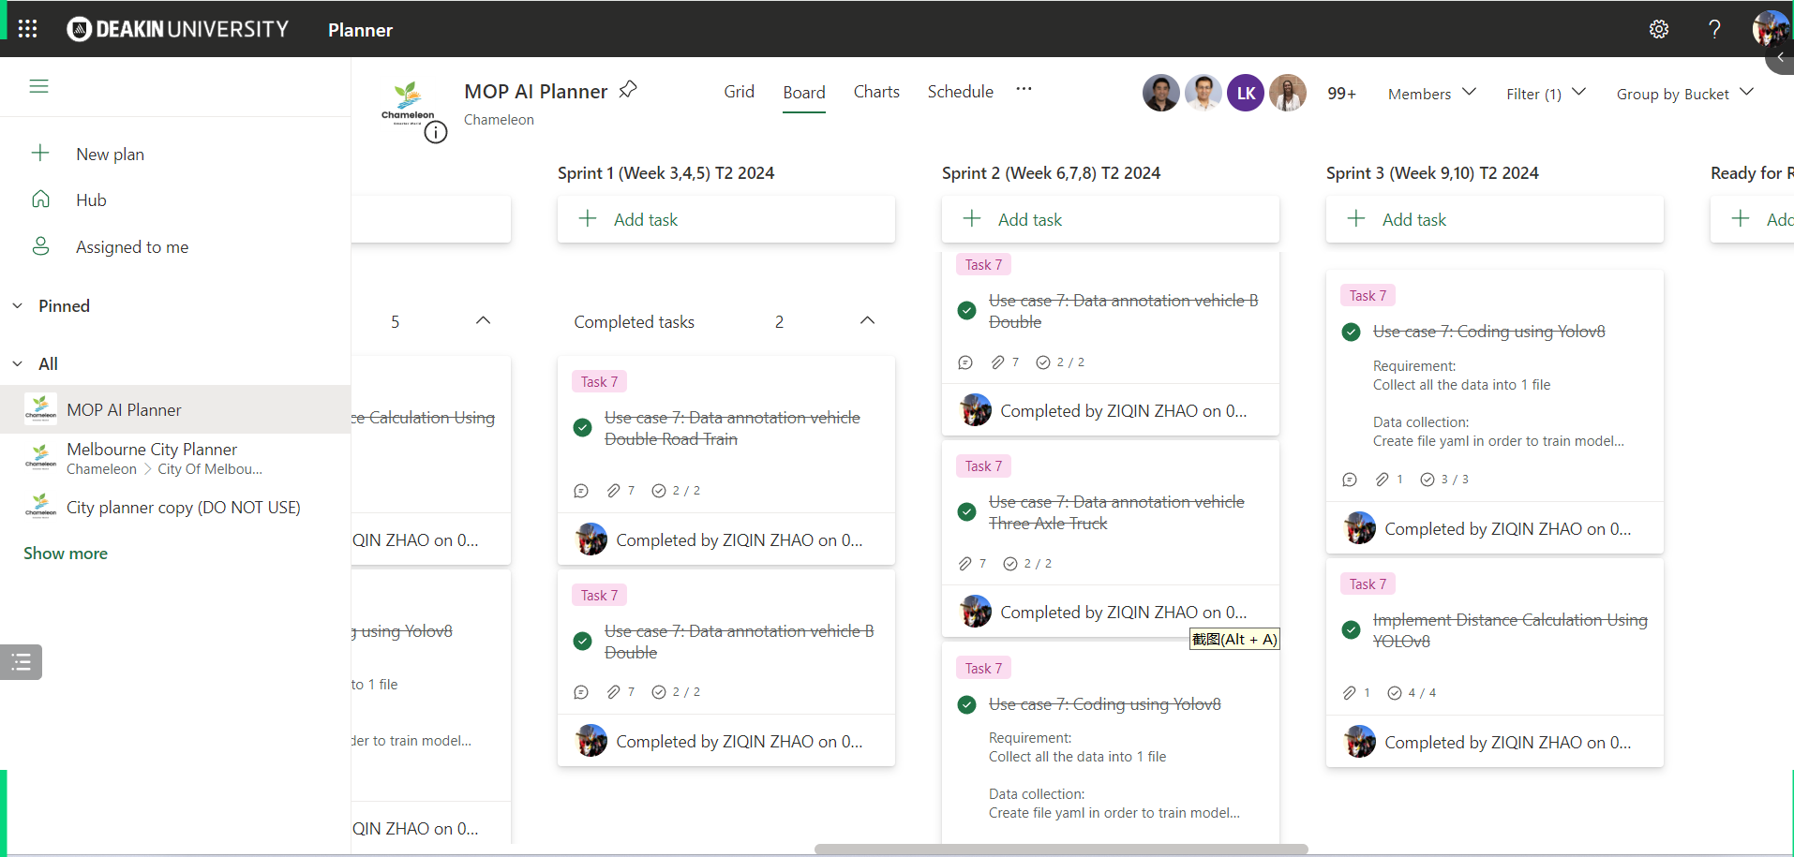

Use case 7: Data annotation vehicle Double Road Train

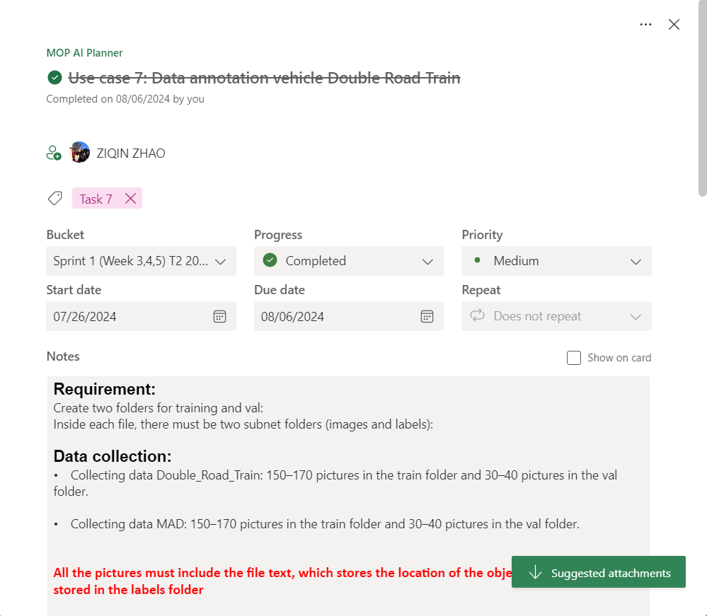

Use case 7: Data annotation vehicle B Double

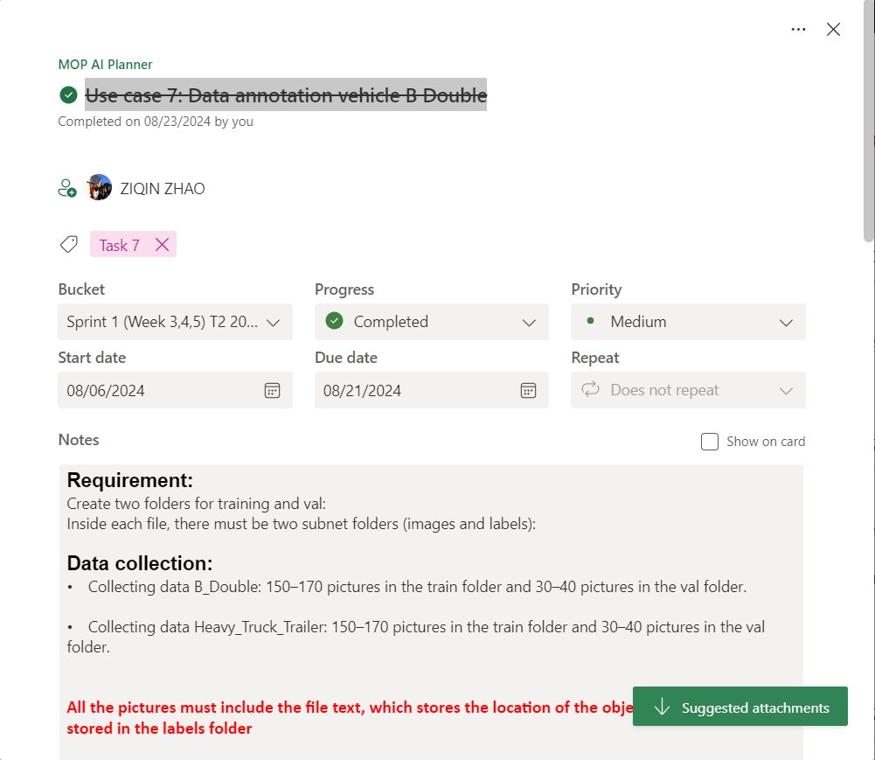

Use case 7: Data annotation vehicle Three Axle Truck

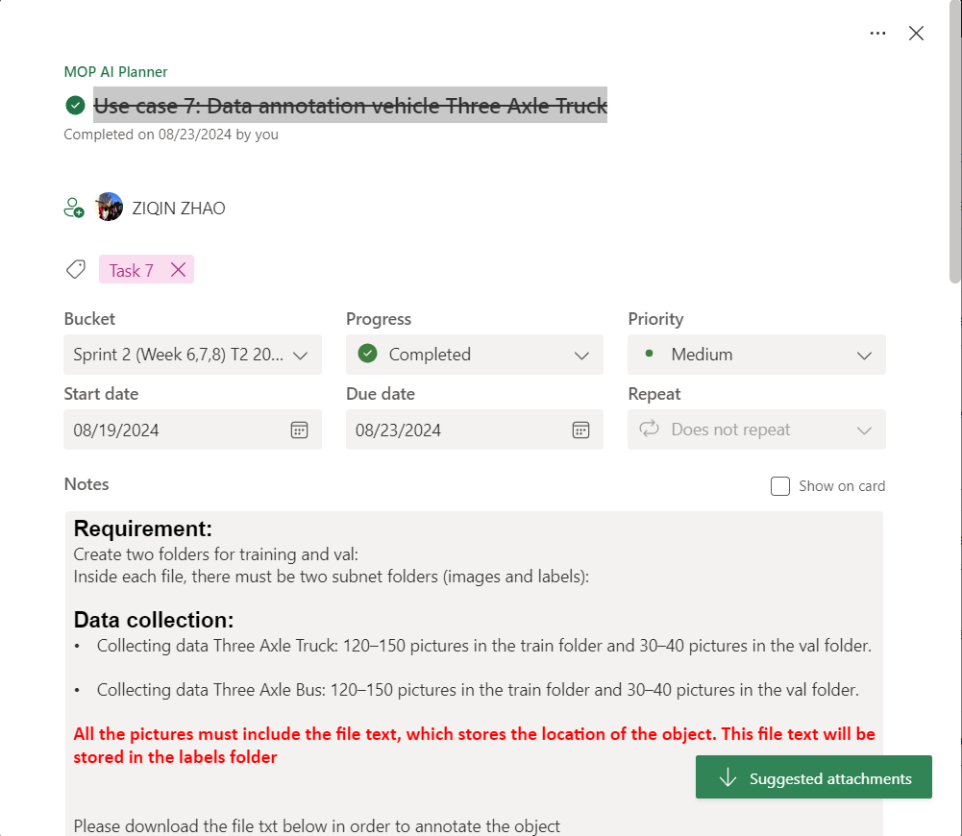

Use case 7: Coding using Yolov8

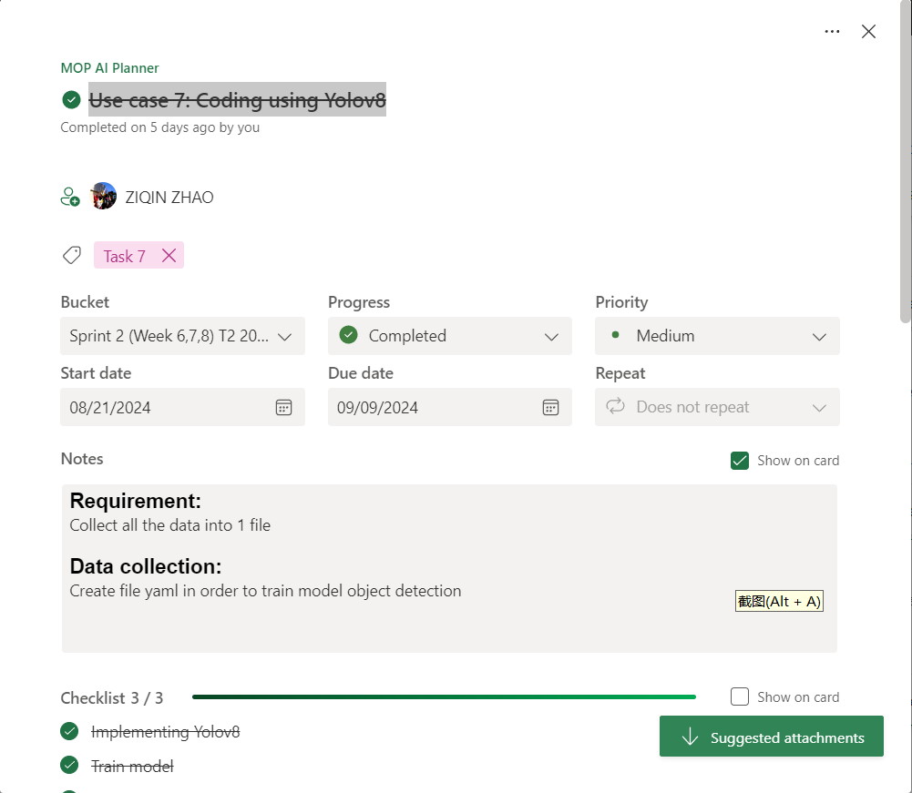

Implement Distance Calculation Using YOLOv8

